10.06
Inventory & Shelf-Life Control
Process Design & AMOS Configuration Document
Purpose
This Process Design document is provided to Key-Users to record their key decisions regarding the AMOS Process design and the required AMOS configuration.
It is updated throughout the Project Definition Phase and used as the baseline for the Final Acceptance prior to Go-Live
Revision
Author, Name | Date | Notes
Marcel Moser | 01.06.2024 | First version

Table of Contents
1. Process Overview & Objectives 3
2. Regulatory References 3
3. Definitions & Glossary 3
4. Process Tasks 4
5. Process Dependencies 4
6. Process Flow 5
7. Process Design Questions 6
8. Data (Source) Mapping 8
9. Other Software Used 9
10. AMOS Configuration 9
a. Basic Data 9
b. Parameters 9
c. Workflows 10
d. Scheduled Tasks 11
e. API’s & Interfaces 11
11. Annex – Additional Info 11

Process Overview & Objectives

Process General Description:
This document describes the flow of tasks to allow the execution of the following activities:
- Execution of an Inventory
- Identification and processing of Surplus Material.
- The move of parts into Quarantine
- The scrap of materials

Main Process Objective (Outputs & Outcomes):
This process allows to perform and generation, execution, and record of an inventory. Furthermore, it also allows the determination of parts in a surplus state, facilitating its eventual selling. Additionally, the scrapping of parts as well the quarantine processes are covered by this document.

Regulatory References

There is no worldwide authority regulation applicable to this process.

Definitions & Glossary

Keywords | Explanation
Inventory Control | The activity of checking AMOS store's and location's stock quantities is performed with the AMOS APN298/Inventory Control.
Location | Locations in AMOS are setup in APN2409/Store Management and defined by "Storage Type, Restriction and Location Type. Which location shall be included within the inventory process can be decided and configured by the AMOS Admin/button "Admin Location Types" (license required)
Annual or Permanent Inventory | With AMOS two types of inventoryes or stock taking can be performed. If all parts are counted once a year (only) it is the annual one, if counting is done all year around step by step we are talking about the permanent inventory.
Inventory Period | The current financial year (set by the scheduler task FinancialPeriodClosingTask) defines the inventory period (parameter 818).
A/B/C - Type | AMOS offers the possibility to segregate parts by min/max average price groups, e.g. “A” part starting from 100'000.00 (most expensive parts).
WMS | AMOS can be linked to any external warehouse management system (WMS).
AMS | AMOSmobile/STORES
Shelf Life | A Requirement which determines if a Consumable needs to be discarded or a Rotable / Consumable, Expendable needs to be tested or sent out for re-certification according to OEM requirements
Storage Requirement | Storage Requirement is a rule based on a defined interval based on calendar days.
FSV | Financial Stock Value

Process Tasks

Business Process Task / Actions / Activities:
- Determination for a schedule for the performance of an inventory. It could be either once a year, or permanent (rolling). This must be determined by the Company’s policies.
- Identification of surplus parts to be sold. This can be driven either by slow moving parts, or an eventual fleet phase out, etc.
- Damaged, expired, or parts deemed not economically viable to be repaired should undergo the scrapping process.

Process Dependencies

INPUT | CONCURRENT | OUTPUT
- 01.02 Parts Definition: Creation of part requirements that limits the shelf life of parts, materials, and tools. | - 10.04 – Part Request Fulfilment: picking of materials required to be sold  - 09.04 – Repair & Exchange: to enable the execution of a scrap.  - 04.04 – Approval Control: to allow the creation of approval policies for Sales Orders | - 12.01 – Financial Accounting: Monitors and controls of accounting postings, for eventual export of data into an ERP solution

Process Flow

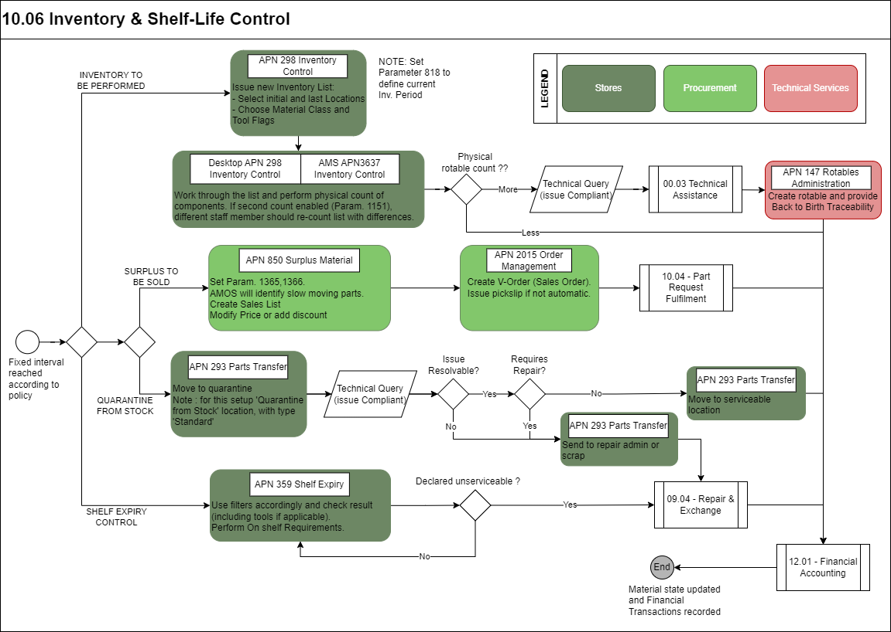

Process Design Questions

# | Question | Answer
1 | [Inventory] Is the location inventory count performed as an intensive annual check or done permanently?  (Please review parameter 818 to configure the appropriate setup).
2 | [Inventory] In case of permanently inventory control, please explain your frequency?
3 | [Inventory] Shall parts on TRANSFER be included in the inventory count?
4 | [Inventory] Shall shelves which are shown with zero system quantity also be counted?
5 | [Inventory] Is on the Inventory Control Report the system quantity required or shall it be left empty, so the user does count the quantity found?
6 | [Inventory] Do you have a value separation in place for the quantity correction allowance for store man or managers?
7 | [Inventory] Will you use a AMOSmobile/STORES (or any other solution) to perform the inventory check? If yes, which one?
8 | [Inventory] In a paper-based process, after the inventory control sheet is booked in AMOS, what shall happen with the physical control sheet itself? Shall it be discarded or scanned and linked
9 | [Scrap] One or two step scrapping process?
10 | [Scrap] Which areas are allowed to start the scrap process?
11 | [Shelf-Life] Who is responsible to check for shelf-life expiry in stores?
12 | [Shelf-Life] What are the current procedures for expired parts?
13 | [Shelf-Life] What’s your current procedure for outstations parts, tools?
14 | [Shelf-Life] How are overdue parts (shelf life, requirement, Tool Calibration) handled?
15 | [Shelf-Life] Do you have Rotables which have a shelf expiry? (Battery's e.g.)
16 | [Shelf-Life] Who is handles the tool requirements?
17 | [Shelf-Life] How frequently do you check your stores for expiry's?
18 | [Quarantine] What is your current quarantine process?
19 | [Quarantine] Who has the right to send parts onto quarantine?
20 | [Quarantine] Do you have a dedicated store for quarantine?
21 | [Quarantine] How do you currently administer this location?

Data (Source) Mapping

Data Sources | Description | Volume / Manual / Automatic / Static / Dynamic
N/A | N/A | N/A

Other Software Used

Other Software | Used by: | Description
N/A | N/A | N/A
N/A | N/A | N/A

AMOS Configuration

Basic Data

Basic Data Table | Notes
N/A | N/A
N/A | N/A

Parameters

Parameter Code | Parameter Name | Notes
813 | Inv.-Control: Max Av.-Price For C-Parts
818 | Current Inventory-Control-Period
812 | Inv.-Control: Min Av.-Price For A-Parts
816 | Inv.-Control: Number of Days B-Parts
912 | EXCLUDE QTY-SYS FROM INVENTORY REPORT
1593 | Sign Closed Inventory Report
1151 | Inventory: Second Booking When Qty-Sys<>Qty-Found
1190 | Show Zero (0) Values in Inventory List
817 | Inv.-Control: Number of Days C-Parts
915 | Inv.-Control: Number of Days A-Parts
1953 | Flutter Apps: Enter date and time manually | This parameter applies to AMOSmobile/STORES
1365 | SURPLUS MATERIAL MAIN PARAMETERS
1366 | SURPLUS MATERIAL ADDITIONAL PARAMETERS

Workflows

Workflow Number | Workflow Name | Notes
153 | Inventory difference has been booked | This workflow is triggered when an inventory-difference is booked and written to the history.
157 | Part Transfer | Workflow triggered before the movement of parts between store locations.
224 | Inventory Changed | This workflow is triggered when an inventory has changed.
339 | Inventory | This workflow is triggered in AMOS module "Inventory Control" as soon as an Inventory List is either created (issued), modified (saved, booked) or deleted.
340 | Inventory Item | This workflow is triggered in AMOS module "Inventory Control" as soon as an Item on an Inventory List is either saved or booked
357 | After Part Transfer | Workflow triggered after the movement of parts between store locations
487 | Consignment Stock Decrease | This workflow is triggered after the consignment stock has been decreased.
503 | Pressing button 'Repair'/'Send to RA' | This workflow is triggered when button "Repair" or "Send to RA" is pressed.
504 | Pressing button 'Perform' | This workflow is triggered when button "Perform" is pressed in Shelf Expiry Control (APN 359)

Scheduled Tasks

Scheduled Task Reference | Frequency | Notes
SurplusMaterialSearchService | Once a week | Service to search for unused parts, overstocked consumables and slow-moving Rotables with the settings defined in the Sales Proposal system parameters.

API’s & Interfaces

Reference | Direction | Trigger | Frequency
N/A | N/A | N/A | N/A
N/A | N/A | N/A | N/A

Annex – Additional Info

N/A

